Kyleigh Bowes

EDUC 387

Equal Sharing class #2

**In equal sharing**

* In equal sharing: Everything must be shared, and must be shared equally
* No coordination: student does not share everything, but what is shared is shared equal
* Non coordinating (repeated halving): share everything, and equally, way they do this (number of children less than coordinating partitioning with number of sharers, not pre planned (happens in the process)

**Repeated halving**

* Repeated halving: everything is cut in half, share half pieces, pieces that are left are then halved, you continue until you have 1 piece left then coordinating between partitioning to the amount of ppl sharing item
* -spilt in half
* -Everyone each gets a half piece
* -split last piece in terms of number of people
* Why? Not thinking about number of people they are sharing with; they are halving because it is an easier method
* More children compared to what is shared vs fewer compared to what is shared
* They are not thinking in coordination with the number 4
* In the other, children coordinate how they partition whole with number of sharers
* Looks different when numbers in problem are different
* As a teacher: number choice is important when giving students word problem
* Chapter says: Halving is a go to way to partition whole, if they have to share it is a way to make sure everyone gets the same amount (might extend to number of children greater than 2 e.g. cut cotton balls in half)

**Additive coordination (groups of items)**

*Number of children greater than number of items shared*

* Groups of item strategy: not partitioned according to the number of sharers, look at way to relate number of children to number of items, creating pieces based on number of sharers
* Coordination looks at part of group, creating number of parts based on number of children
* Looking at a group of items shared, partitioning groups of items so each child get a piece of that group
* E.g have 2 chocolate bars and want to create 10 pieces

**If you want to move student from Additive coordination (1 at a time) to (groups of items at a time)**

* Have a problem where the number of children is less than number of items shared (don’t have to think of partitioning every whole in the same way)
* easier to look at group of items bit by bit
* Always thinking of number of sharers but not partitioning whole in same way easier to move toward this strategy when number of children is less that # of items shared
* Need evidence that pieces shared match the number of children each time

**Additive coordination (sharing 1 item at a time)**

* Take each whole, partition in accordance to number of children

**Ratio (repeated halfling)**

* Children use different number than the one in problem
* Compare number of items to the number of children
* Repeated halving: the number of children and item at same time (splitting # f children and what is being shared at same time (e.g. how many children sharing how many subs: 4 children sharing 2 ½ subs)
* Children that use this strategy Understand equivalent ratios, using higher level of fractions that is not dependent on the problem (if it was it would be sharing), using different meaning of fractions not elicited in the problem
* Need to have an even number of children to elicit this strategy (can't split child in half)
* Will have number of children and items shared until get to # of odd children
* They don’t need context of the problem, even if problem elicits equal sharing and division, they are using different thinking without partitioning or sharing

**Ratio (Factor)** e.g.: 4 children share 10 cookies

* Both numbers must have a common factor
* E.g 5 things shared with 2 ppl

-Additive coordination: Child starts by splitting the first item to be shared in exactly as many parts as there are people sharing, repeat process until each item is shared

-Ratio: repeated halving and ratio (factors)

-Trial and error: When children learn to conceptualize partitions beyond halving and repeated halfing, develop small knowledge of fractions to use in solutions for equal share problems

-Nonanticipatory sharing: Students do not start with a plan on how to share everything equally and completely, students work out as they go to make sure everyone gets the same amount and everything is shared.

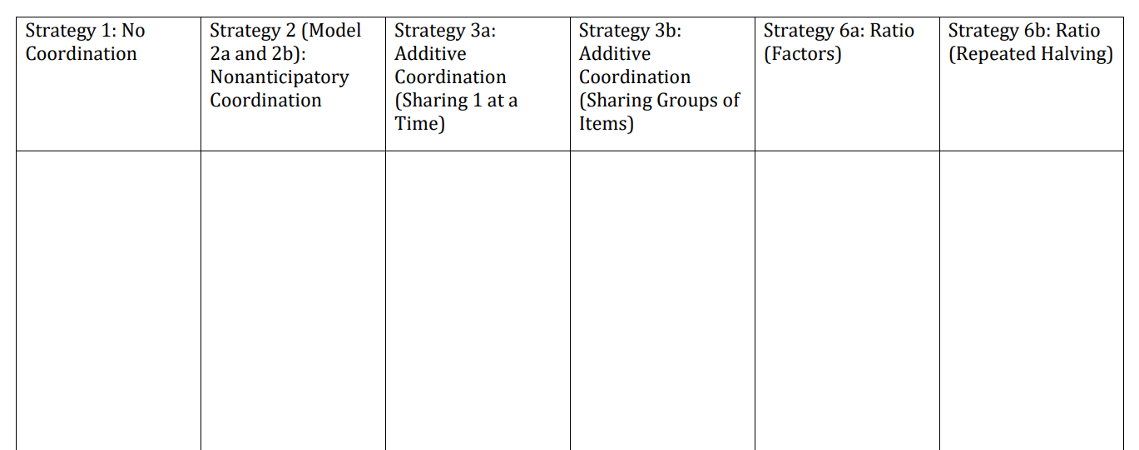

* Refer to problem set #6, and the teacher will post photos of the solutions we solved in class !!